

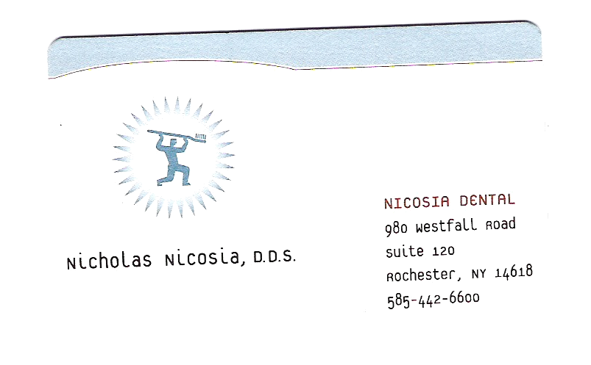
Strategic Marketing Plan
For
Nicosia Dental

Version 1.0
November 18th, 2005
Principles of Marketing – Fall 2005
Dr. Neil Hair

Presented by:
Mandy Bianchi, Justin Crandall
Wesley Dillingham, José Plaza, Erica Stoll
Contributors
Role | Name | E-Mail Address
Author | Mandy Bianchi | Whitemint81@aol.com
Author | Justin Crandall | Jdc5173@rit.edu
Author | Wesley Dillingham | Wwd6291@rit.edu
Author | José Plaza | Jap6309@rit.edu
Author | Erica Stoll | Egs0862@rit.edu

Document Version | Version 1.0
Document Name | Strategic Marketing Plan Campaign for Nicosia Dental
Date Created (Draft) | 12 November, 2005
Date Approved | 18 November 2005
Location | Rochester Institute of Technology - Rochester, NY
Medium of Distribution | Direct Business-to-Client

Legal Disclaimer:

Worthington Consulting, consisting of Amanda Bianchi, Justin Crandall, Wesley Dillingham, José Plaza, and Erica Stoll, Rochester Institute of Technology and Its affiliates, Dr. Neil Hair, and all parties involved in the consultancy project with Nicosia Dental are not to be held legally responsible for any tribulations incurred through the implementation of this proposal. All information contained within this document is the property of Worthington Consulting. Furthermore, the research information contained within this document is held to be accurate and was obtained legally. The participating parties will not, under any circumstance be held responsible for any financial loss or diminished value of personal reputation.

PREPARED: DATE: ___/___/___
(for acceptance) (Mandy Bianchi, Document Owner)

PREPARED: DATE: ___/___/___
(for acceptance) (Justin Crandall, Document Owner)

PREPARED: DATE: ___/___/___
(for acceptance) (Wesley Dillingham, Document Owner)

PREPARED: DATE: ___/___/___
(for acceptance) (José Plaza, Document Owner)

PREPARED: DATE: ___/___/___
(for acceptance) (Erica Stoll, Document Owner)

ACCEPTED: DATE: ___/___/___
(for release) (Dr. Neil Hair, Marketing Instructor)
DOCUMENT ACCEPTANCE and RELEASE NOTICE
This is version 1.0 of the Nicosia Dental Marketing Plan.
Worthington Consulting has designed this marketing plan uniquely for Nicosia Dental. The foundation of this marketing plan revolves around the five question marketing model which Worthington Consulting used to effectively audit Nicosia Dental’s status in their current market, and effectively plan out a method to recognize company goals. In conclusion, various options will be displayed, with the best being selected.
- Where are we now?
- Where do we want to be?
- How might we get there?
- Which way is best?
- How do we ensure safe arrival?
Throughout this marketing plan, there are numerous charts and graphs depicting actual marketing models. The idea of these models is to analyze the dental practice in detail. All of the models include an explanation of their purpose, along with a connection as to how they help evaluate Nicosia Dental. In addition, an appendix is included within this marketing plan, which consists of actual resources, data, and straight derivatives that were used during this marketing analysis. Proposed marketing solutions are included as well. All include methods of implementation, along with monetary figures and companies to contact.
The Nicosia Dental Marketing Plan is a document managed by Worthington Consulting. For identification of amendments, each page contains a page number and date. Changes will be issued only as a complete replacement document. Recipients, in this case Nicosia Dental, should remove superseded versions from circulation after a request for an updated version of the marketing plan has been issued. This document is authorized for release after all signatures have been obtained.
Please submit all requests for changes to Worthington Consulting.

Sincerely,
Worthington Consulting

TABLE OF CONTENTS
Executive Summary 7
Objectives 8
Overview 8
where are we now 9
History of Nicosia Dental 9
Demographics 9
sports dentistry 12
Overview 12
Nicosia Sports Dental 12
heuristics analysis 13
SWOT Analysis 13
Ansoff Growth Matrix 14

Marketing Mix 15

Porters Five Forces 16

Segmentation, Targeting and Positioning 18
competitor(S) Assessment 18
where do we want to be 21
Marketing Focus – SMART Objectives 21
Porter’s Generic Strategies – Differentiation 23
how might we get there 24
marketing research and relationship marketing 24
communications, pricing, and promotional strategies 27
which way is best 30
how do we ensure safe arrival 31
Honest Appraisal 35
Appendices 36
Appendix A - Nicosia Dental Patient Survey 36
Appendix B - Patient Survey Tallied Results 37
Appendix C – American Dental Association Search Query for Dr. Nicosia 39
Appendix D – Yellowpages.com search results for Dr. Nicosia in Rochester 40
Appendix E – SportsDDS.com: A Sports Dentistry Website Based in NYC 41
Appendix F – Sportsdentistry.com: Online source for Sports Dentistry 42

Executive Summary
The members of Worthington Consulting present the following marketing plan with pride and honor. The subsequent contains a comprehensive audit and evaluation of the current standing of Dr. Nicosia’s Dental practice located at West Fall Road in Brighton, New York.
Worthington Consulting began the auditing process with a personal encounter with the business. Several aspects of the businesses staff, waiting room, operatories, and dentist were evaluated. Dr. Nicosia then met with the consultancy group in order to give a better understanding of the business’s history and current standings from their own point of view. This was very beneficial to the consultants to allow a credible analysis of current market standings.
In order to gain more information on clients and competitors, questionnaires were issued. These documents once completed by several of Dr. Nicosia’s patients were critical to allow our consultancy to see possible areas that needed to be improved and where the practice was flourishing. The completed questionnaires assisted in directing decisions to customize a new plan for the practice.
Worthington Consulting then looked at possible competitors to Dr. Nicosia’s practice. After defining these competitors the consultants were able to see where any gaps may be, and where Dr. Nicosia had a competitive advantage over others in the area.
Worthington Consultants developed objectives for the practice that were specific, measurable, agreed, realistic, and time related, to base the rest of the implementation process off of. This objective allowed the consultancy to evaluate several options to obtain a suitable solution(s) for the client.
Focusing on Sports Dentistry and retaining current customers is the best way to achieve the objective that Worthington Consulting has established. The research team intends on basing off of Dr. Nicosia’s current affiliation with local Rochester sports teams to help bring in new customers. Although the affiliation exists, most clients are not familiar with it. This is the main differentiating factor of the practice.

Objectives

*Our Main Focus Will Be Nicosia Sports Dentistry and Current Patient Retention*

Overview
Using the financial figures Nicosia Dental provided, Worthington Consulting has devised a marketing plan. The research team has worked with budget limit of $10,000 to devise a clear and effective marketing plan that will provide results far exceeding the figures Nicosia Dental is currently experiencing.
Worthington Consulting has devised a three-fold marketing plan, consisting of three separate clienteles which we hope to target. They consist of existing customers, sports-affiliated prospective clients, and as new residents to the Rochester area, whom we will refer to as “Rochesterians.” For his existing clientele, we will use relationship marketing, as well as Customer Relationship Marketing techniques (CRM) to further develop his loyal customer base.
In the case of attracting new clients, broken down into sports-affiliated client prospects and new Rochester residents, Worthington Consulting has devised a marketing strategy that will consist of increasing awareness, both for Nicosia Dental and the practice’s differentiating role in Sports Dentistry, to spread the word to the general target markets. The goal is to eventually create an effective branding campaign, with Nicosia Sports Dentistry as its backbone, to attract sports dentistry customers and general dentistry patrons.
In the end, Worthington Consulting wishes to effectively launch an awareness campaign for Nicosia Dental, which will reestablish the high-quality general dentistry aspect of the practice, as well as lucratively use Dr. Nicosia’s specialization in Sports Dentistry to obtain more clientele and thus, produce revenues for our client.

where are we now

History of Nicosia Dental
Dr. Nicosia operates one of 74 active dental offices within a one mile radius of his practice. Considering the small area, there is certainly a lot of competition within the market that Dr. Nicosia is involved with. The following analysis will help us understand who Dr. Nicosia is and what makes his dental practice both the same, and different, than other dentists.
Dr. Nicholas Nicosia, D. D. S. has been in the dentistry field for 18 years. Nicosia dental was originally passed down to him by his father, who ran a successful reign of the business. The office was originally on East Avenue in downtown Rochester. Nicosia dental offers current patients the usual services other dentists offer, such as the cleanings and x-rays. Nicosia dental also provides fillings, resin fillings, crowns, bridges, and implants.
Though these services can be found in most other dental practices, it should be pointed out that their services are of higher price, due to the fact that experience and first-rate quality go into these procedures.
After speaking to Dr. Nicosia, Worthington Consulting gathered that the current marketing drive in place for Nicosia Dental is made up of a yellow pages business listing and general word of mouth. This current implementation has provided Nicosia Dental with an average of 10-15 new patients a month, bringing in a yearly total of at least 120 new patients.
In addition, “Smile of the Game,” a program affiliation with the Rochester Americans, does not include personalized objects that would link the Amerks to Dr. Nicosia.

Demographics
Nicosia’s Dental Practice current clientele is described by the following statistics derived from actual figures in office records:

Patient Data
Total Patients: 3483
Age Range: 1-105 (Largest Percentage composed of mostly 31-41 yr olds)
Current Clientele: 60% seen twice a year, 40% seen four times a year

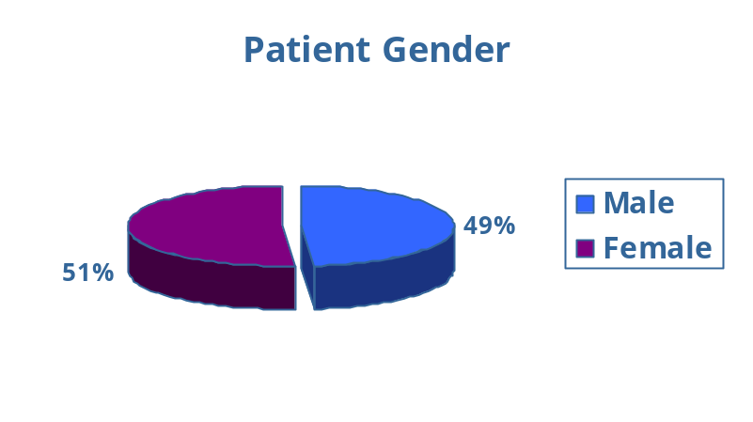
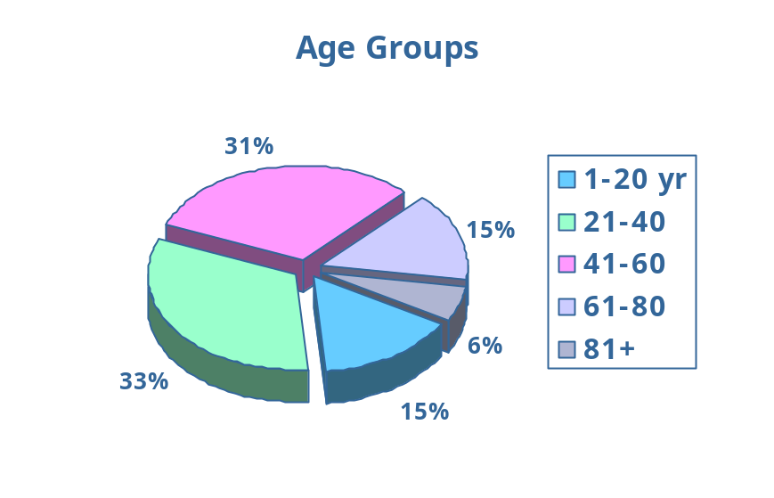

Nicosia Dental finds it very important to obtain and display demographic information in order to better understand their current position within the dental industry. The research team will further use this information to adapt the marketing plan as best as possible to these specific demographics.

Nicosia Dental also has records of referrals and has provided Worthington Consulting with the latest figures. The following data shows percentages of referrals and their origination:

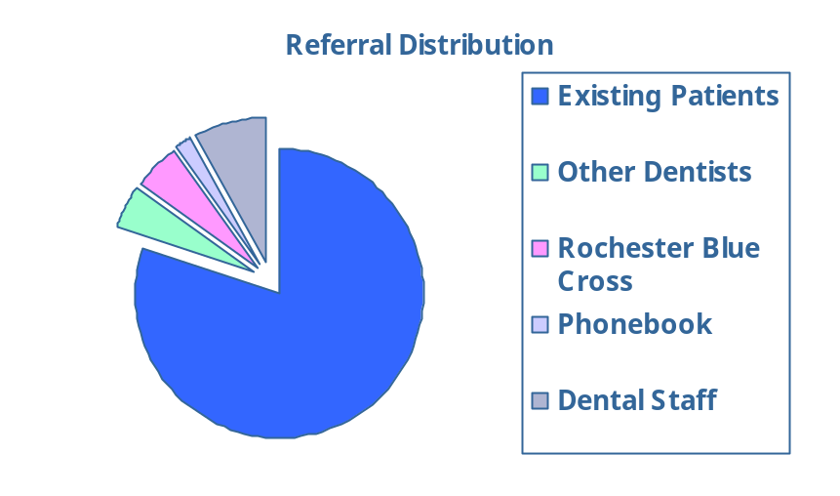

Worthington Consulting obtained an up-to-date pricing list from Nicosia Dental during the initial consultation, which allowed for the research team to evaluate the current pricing strategy and policy. This information will allow us to look at how the client’s prices compare to those of his competitors. In addition it was learned that the major insurance provider Nicosia Dental accepts is Blue Cross Blue Shield which greatly impacts the selection of clientele.

The current average fees of Dr. Nicosia’s practice are as follows:

Dr. Nicosia’s Dental Practice
Cleaning | $77
X-Rays | $127
Restorative fillings | $135+
Resin Fillings | $101-170
Crowns | $800-900
Fixed Bridges = an average three-unit bridge | $2400
Extensive Implant Restoration | $1600/tooth

sports dentistry

Overview
After speaking with Dr Nicosia and taking a tour of his office, Worthington Consulting discovered another aspect of his dental practice: Sports Dentistry. This aspect of dentistry is quite unique to a practicing dentist. Sports Dentistry is “the treatment and prevention of oral/facial athletic injuries and related oral diseases and manifestations.” This aspect of dentistry looks particularly after professional and non-professional athletes, and works with prevention methods such as mouth guards, as well as restorative procedures that follow sports injuries, like broken/chipped/avulsed teeth, and other injuries.
In sports, the challenge is to maximize the benefits of participation and to limit injuries. Sports Dentistry has a key role to play in this area. Prevention and adequate preparation are major elements in minimizing injuries that occur in sports. Dental injuries are the most common type of oral facial injuries sustained during participation in sports. Most of these injuries can be prevented by the use of proper fitting mouth guards. Sports Dentistry also includes the need for recognition and referral guidelines to the proper medical personnel for non dental related injuries which may occur during a dental/facial injury. These injuries may include cerebral concussions, head and neck injuries, and drug use. As health professionals dentists should be able to recognize these entities and refer these patients to the proper medical personnel.

Nicosia Sports Dental


Dr. Nicosia is currently serving all the professional Rochester Sports Teams as their team dentist. The list includes:

Rochester Americans (Amerks) – Hockey
Rochester Raging Rhinos – Soccer


Rochester Rattlers – Lacrosse
Rochester Red Wings – Minor League Baseball
Rochester Knight Hawks - Lacrosse
Rochester Razor Sharks - Basketball


Nicosia Dental is fairly well-established in the Rochester Professional Sports world. One of the goals of Nicosia Dental will be to expose this further and attract new potential sports clientele, looking specifically at the collegiate level. As mentioned earlier, Dr. Nicosia is an official sponsor of the “Smile of the Game” program with the Rochester Amerks

heuristics analysis

SWOT Analysis
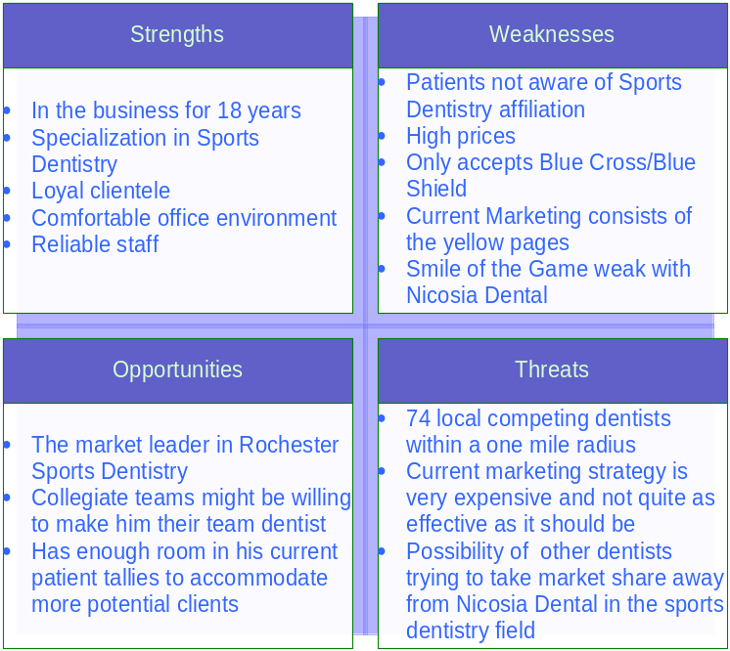

The results of this SWOT analysis shows the strengths, weaknesses, opportunities, and threats of Dr. Nicosia’s Dental Practice and of the Consultancy’s objectives to increase the awareness of sports dentistry in the Rochester area. To further explain the SWOT analysis as a heuristic the research team will begin by delving into each of the areas of what the SWOT represents and the principle objectives that it is to achieve.
To summarize the key elements of the four dimensions the research team will begin with strengths being the areas of distinctive competence that must always be looked at relative to the competition. If managed properly they are the basis for competitive advantage. The strengths are derived from the marketing asset base. The weaknesses are the areas of relative disadvantage that indicates priorities for marketing improvement. The weaknesses also highlight the areas and strategies that the marketing planner should avoid. The threats indicate the trends within the environment with potentially negative impacts that increase the risks of a strategy, hinder the implementation of strategy, increases the resources required, and reduce performance expectations. Opportunities are environmental trends with positive outcomes that offer scope for higher levels of performance if pursued effectively.
The SWOT analysis is therefore designed to achieve two principle objectives: to separate meaningful data from that which is merely interesting, and to discover what management must do to exploit its distinctive competencies within each of the market segments, both now and in the further. The purpose of strategy formulation is to develop a system that will take advantage of the opportunities and overcome the threats.

Ansoff Growth Matrix

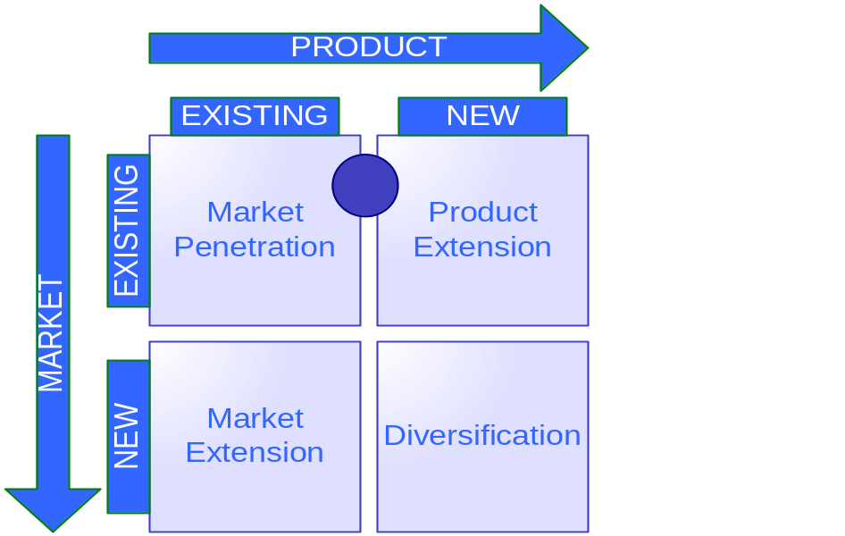

The Ansoff Growth Matrix is used to justify in which direction a marketer would like to take a company. Using this model, it is clear to see where a business currently stands, and where it should move towards.
Worthington Consulting believes that Dr. Nicosia’s practice is currently located between the first two quadrants. The first quadrant that the practice falls into is market penetration. This includes selling existing products to existing markets. The practice is selling dentistry to current clients. Worthington Consulting is not changing the product, but changing the focus.
The second quadrant that the practice falls into is product extension. This is extending existing products into new markets. Again, there is no intention of changing the product being offered, just the way it is presented and the awareness that the product is being offered. It is felt that this will take the business’s current product into new markets that include both the strong and weak target markets. Our strong target market includes customers that are interested in Sports Dentistry. The weak target market is compiled of potential customers that are indifferent to his affiliation with sports dentistry.

Marketing Mix
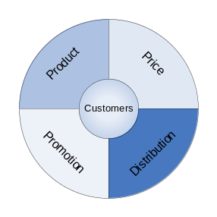
Manipulation of the marketing mix can create a differential advantage within market by which a distinct competitive position can be established. The marketing mix traditionally consists of the four P’s of marketing: price, promotion, product, and place/distribution. Price can be further broken down into pricing structures, discount structures, and terms of business. Examples of promotion are advertising, sales promotion, public relations, personal selling, merchandising, and sponsorship. Products are considered the product management, new product development, and branding. Place/distribution is channel management, customer service, and physical distribution. Also included in the marketing mix are the three soft P’s which include process management, physical evidence, and people. Process management can be described as how customers are handled and managed from the first point of contact to the last. Physical evidence is the layout, décor, and ease of access to the business. The people segment includes employee selection, employee training, and employee motivation.
Worthington Consultants have defined the marketing mix for Dr. Nicosia’s Dental Practice as follows. The product that he is offering is sports dentistry to new and existing patients. Dr. Nicosia’s Sports Dentistry will be promoted through a re-constructed Smile of the Game gift bag, The Reporter, radio and television advertisements, realtor’s and apartment complexes for people new to the area. Price and distribution will not be modified upon for Dr. Nicosia because as a whole it has been decided that it cannot and will not change. The three soft P’s of the marketing mix will be used for Dr. Nicosia as the consultancy group have deemed fit for his practice. The process management of the office will ensure continual care of the patients from the first contact with the receptionist, a welcoming and friendly assistant/hygienist to greet and seat the patient on a casual personable level, contact with Dr. Nicosia whether he has worked on the patient or not, and ending with the receptionist for payment and any questions that the patient has about future appointments and/or billing. The physical aspect the company is comprised of its layout, décor and ease of access. Dr. Nicosia’s office will not be changed due to the patient responses of appreciating the comfortable office environment. Dr. Nicosia’s staff is loyal, hard-working and has dedicated themselves to there position in the office. To increase employee motivation if need be, Dr. Nicosia can have yearly employee reviews to let them know how well they have done over the past year and what they can work to improve on for the next year.
The objectives of the marketing mix are to evaluate and audit current marketing strategies and to decide if and where any changes need to take place. The marketing mix can and should be re-evaluated over time to visualize where the company stands in the services sector.

Porters Five Forces
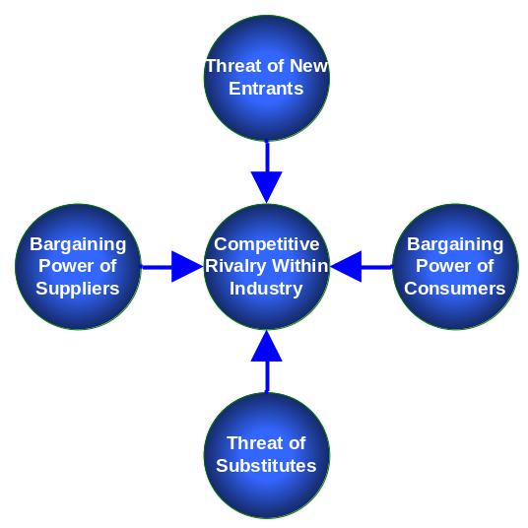

The objective of the five forces is to observe and monitor the current competition as well as internal forces which effect the businesses interactions with other entities. By using the five forces, the company can analyze and compare their position with their competitors to gain perspective of the market and to use this knowledge to become the market leaders. Porter’s Five Forces represent the forces governing the nature and intensity of competition within an industry. They are the background against which the choice of a generic strategy should be made. Consumers, suppliers, substitutes, new entrants, and rivalry throughout the industry each play a part in positioning the company’s competitive strategy.
These five forces can be used by Dr. Nicosia beginning with the threat of new entrants. The threat of new entrants is a possibility but would be considered a minimal threat. Dr. Nicosia already has a large market share of sports patients through his existing clientele. Any new dentists would be considered market followers and are highly unlikely to achieve any greater amount of clientele. The bargaining power of consumers is also a minimal threat. According to the patients that were contacted through anonymous questionnaires and that we spoke to personally, they were all extremely pleased with the office and with the staff. New patients on the other hand have higher bargaining power, so it is up to Dr. Nicosia and his staff to refer back to the marketing mix and to impress new patients with process management. This will ensure that they will return for their second visit and become regular patients. The threat of substitutes will not be touched upon because there is no substitution for sports dentistry, only a new threat of entrants. As for bargaining power of suppliers, Dr. Nicosia has the upper hand in this area. He can pick and choose suppliers as he deems fit for his practice. Competitive rivalry within the industry is minimal according to Dr. Nicosia. As a consulting group it is believed that this is not true. Whether the competition is direct or indirect it is there because dentists always need patients. They will recommend themselves before they recommend a friend. Dr. Nicosia can use this to his advantage because he will be the only sports dentist in the Rochester area. Competitors may be more inclined to refer patients to him just for his reputation as a sports dentist. Dr. Nicosia can choose not to refer patients out to a specialist because of his expertise in the area and because patients will choose to see him instead.
McKinsey’s Seven
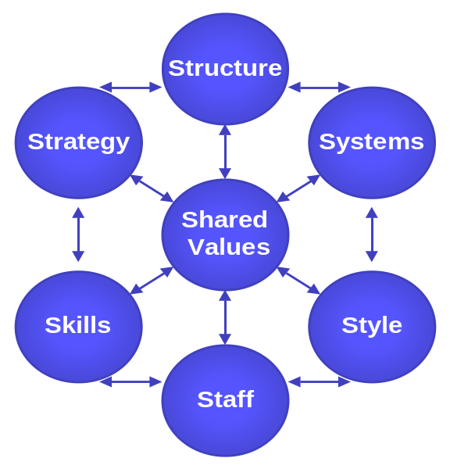
McKinsey seven is a way to establish how a business is currently set up. Each portion of the model is related to another. For this reason, if one of the pieces of the model changes, each portion is also effected in some way.
Worthington Consulting will use this model to get a stronger understanding of Dr. Nicosia’s dental practice and the current working environment.
Using information that has been acquired through meeting with Dr. Nicosia and from the consultants audit upon arrival, Worthington Consulting will evaluate the strengths and weaknesses shown in the various areas. The focus will be on four primary sections, shared values, skills, style, and staff.
The shared values include the genuine service that is rendered during office visits and telephone interactions. Dr. Nicosia’s practice has a focus on providing exceptional care and treatment to its patients at all times.
Dr. Nicosia’s practice has many skills that help to make it such a successful business. The doctor has been practicing dentistry for eighteen years, giving him knowledge and experience that a dentist just graduating from school would not yet have. His specialization in sports dentistry helps him stay up to date with any new innovations in the restoration and implant field.
The staff of Dr. Nicosia’s dental practice is a critical part of what makes the business so successful. Patients strongly appreciate the ability to request which hygienist they wish to be with during their visit. This makes an unpleasant trip to the dentist much more comfortable for customers. The friendly and knowledgeable reception staff makes scheduling appointments and acquiring directions to the office enjoyable and warm.
The style of the office is professionalism in every way. The office is clean, orderly, and precise. It is easy for a patient to forget that they are actually at a dentist’s office. The operatories are organized and each have large windows adjacent to the chairs, allowing patients to gaze out into the sky and maybe even relax during their routine dental appointments. Together, all of these parts work in unison to maintain and create the business that is Dr. Nicosia’s dental practice.

Segmentation, Targeting and Positioning
In order for a successful marketing plan to be implemented the customers need to be specifically identified into distinct groups for Dr. Nicosia to aim to satisfy them better than any of his competitors. To further explain, segmentation is grouping together customers with similar requirements into distinct subgroups within the market. Targeting is the process of deciding which market segment the company will actively pursue, further breaking down the segmented groups into subgroups. Positioning is the way in which a company is perceived by the target market, relative to its competition, against important attributes.
Dr. Nicosia can utilize his patients segment into patients that are interested in sports themselves or just the idea that he is affiliated with sports and who also live in the Rochester area. He can further target that segment by targeting college sports teams. Most college students are from out of town and may need a dentist in case of a sports injury and for further care during their time in college. Dr. Nicosia can position his practice to his target market by advertising his services in areas that would attract sports affiliated patients such as the Smile of the Game gift bag, The Reporter, and radio and television advertisements.
The objective of segmentation, targeting, and positioning is to start with the client, find their pattern, and be able to use this information to successfully compete with the competition.

competitor(S) Assessment
As part of the marketing audit conducted, Worthington Consulting completed a thorough analysis of Nicosia’s dental practices main competitors a vital part to marketing research. Focusing directly on the main competitors, data was obtained from the respective dental practices. Once all necessary facts were gathered, it helped to establish the current position of Nicosia’s competitors. This developed a basis of comparison among the various practices in the Rochester area of concern to us.

Local Competitors

Periodontal Centers of Rochester (Dr. Caton, Dr. Blieden, and Dr. Romano)

The Periodontal Centers of Rochester are considered a competitor to Dr. Nicosia because they also service clients in the field of implants. They specialize in procedures dealing with the gums. The Dentists in this particular practice are highly experienced. Dr. Jack Caton is world renowned for his studies in the dental field. He not only practices but researches and teaches as well. His diplomatic status draws in customers to willingly pay the higher prices for the advance services him and the other dentists of the practice offer.

Periodontal Centers of Rochester
Cleaning | $89.00
Consultation | $95.00
X-rays | $105.00
Implant | $1600.00

Dr. Shtoyko (General Dentist)

Dr. Shtoyko is considered a competitor because he also is a general dentist in the Rochester area. His prices are lower then Dr. Nicosia’s which has an impact on patients that are not able to pay the higher prices that some dentists offer.

Dr. Shtoyko (General Dentist)
Cleaning (adult) | $95.00
Cleaning (child) | $76.00
Consultation | $45.00
X-rays | $76.00
Fluoride Treatment | $18.00
Crown | $834.00
Restoration 1 Surface | $108.00
Restoration 2 Surface | $182.00

Dr. Ronzo (General Dentist)

Dr. Ronzo is a general dentist on Culver Road in Irondequoit. He is considered a competitor because even though he doesn’t perform implants on his patients, he creates the crowns and finishes off the procedure. In addition to that, he also serves in the general dentistry field. His prices are lower than Dr. Nicosia in most aspects of the services provided. Just as mentioned with Dr. Shtoyko, patients may be swayed to pursue dental services from another dental practice if price competition persists.

Dr. Ronzo (General Dentist)
Cleaning | $63.00
Consultation | $41.00
X-rays | $107.00
Fluoride Treatment | $18.00
Crown | $924.00
3-Unit fixed bridge | $108.00

Major National Brand Competitors - Crest/Colgate
Over-the-counter products are a minor competitor of Dr. Nicosia’s dental practice, but should still be taken into consideration. When discussing over the counter products, we refer to at-home whitening kits, electric toothbrushes, fluoride rinse, as well as sensitive toothpaste products. Once only available through doctor prescriptions, these products can now be found in dental care aisles in stores, for a fraction of the cost.
It is very simple for the average Rochesterian to access these products and implement them into their hygiene routine in place of going to an actual dentist. Inflation has caused people to be more frugal about their spending habits. People that strongly dislike going to the dentist, have any phobias, or simply don’t have the financial abilities, may see these products as an alternative. Worthington Consulting believes that over a long period of time, the losses in sales due to substitute products offered by these ever-evolving companies that may accumulate substantially. This is why we view major national brand competitors as a minor obstacle to Nicosia Dental, even though they are not local competitors.

Crest/Colgate (products)
Crest Cavity Control | $3.99
Mouth Wash | $4.49
Crest Night Effects | $18.50
Crest Whitening Strips | $39.99
Dental Floss | $2.00
Toothbrush | $1.00-5.00
Electric Toothbrush | $20-160.00

Summary- Plan of Attack
All of the above competitors, and other local dentists not mentioned, will be the focus of our plan of attack on the competition. Each competitor will be addressed in a different fashion.
General dentists in the Rochester area, such as Dr. Ronzo and Dr. Shtoyko, will be addressed by focusing on the status of Dr. Nicosia. Since he has experience with professional sports teams it is assumed that he is one of the premiere dentists in the area.
Specialist in the area, such as the Periodontal Centers of Rochester, can be very costly, even more so then Dr. Nicosia. They also are not general dentists, which can be difficult for new customers to get referrals to. As a result, unless a customer is a current client of Periodontal Centers of Rochester or other specialists, they will be easy to compete against with advertising through brochures to new potential clients.
Crest, Colgate and other over the counter brand products are also a simple competitor for the practice to overcome. If the focus on premium service and fantastic care are emphasized, it will be simple to see how a product pales in comparison.

where do we want to be

Marketing Focus – SMART Objectives
Worthington Consulting feels that moving towards sports dentistry would be a key area for Dr. Nicosia’s practice to focus. We would like Dr. Nicosia to be known for sports dentistry. Of course, not exclusively, since we also want to promote his high-quality expertise in general dentistry. We feel, however, that this will work as a brand for him, and thus, will help spread the word about his name, his practice, and his expertise in general dentistry as well as sports dentistry. The idea is to make Nicosia Sports Dentistry a brand that will provide results. It will not only attract potential customers; it will also help retain current ones with a boost in Dr. Nicosia’s reputation and area of expertise. With that said, Worthington Consulting developed the following S.M.A.R.T Objectives that pave the way for where Nicosia Dental wants to be.

S.M.A.R.T. Objectives
Specific
Measurable
Agreed
Realistic
Time related

Specific
Establish Nicosia Sports Dentistry by using this specialization as our mode of differentiation

Focus on intercollegiate sports teams/aficionados and new incoming Rochesterians

Increase awareness of Nicosia Dental

Maintain current clientele

Measurable
Expand to 25-30 new patients a month (300-360 in one year), which equates to full capacity (current marketing produces 10-15 new clients a month)

Set patient loss limitations at a maximum of 1% per year, for example, 3.4 patients, at most, currently

Agreed
Dr. Nicosia is currently the market leader in local sports dentistry (official team dentist for Rochester professional sports teams)

Dr. Nicosia agrees: promoting awareness of his specialty in sports dentistry will bring in new patients and maintain current ones

Realistic
Financial backing is available for marketing ($10,000 marketing budget)

Current availability to fill practice to full capacity is approved

Established contacts in the sports industry will help to promote Dr. Nicosia as “Rochester’s Sports Dentist.” (Rochester sports team’s websites, “Smile of the Game” will be used as venues for promotion)

New Rochester residents move into the area yearly: 297 in 2004

Time Related
Significant results will be seen in 6 to 12 months. This time period allows new incoming residents to adjust into the area, as well as for the RIT Hockey team to complete its season

Main Objective: 25-30 new patients monthly (300-360/year) using sports dentistry as our main differentiating factor.

Worthington Consulting has come up with the following objective for Dr Nicosia’s practice, and where we would want them to be. Within one year we aim to bring in at least three hundred new patients using sports dentistry as our main differentiating factor. For new prospective patients, our objectives will help Dr. Nicosia stand out from other local dentists since his practice is established beyond general dentistry. That will be a crucial factor in our opinion, for when new incoming residents decide to choose their dentist. We feel that differentiation will also justify the current prices of the practice. This will help people feel secure with the dentist, knowing that he is worth what the fees are costing them. This is especially important for existing customers that may be thinking of switching dentists due to higher costs. Therefore, differentiation will help retain customers as well.

Porter’s Generic Strategies – Differentiation
Worthington Consulting believes Dr Nicosia’s practice is a market leader. In the field of sports dentistry he has the greatest market share. We feel the competitive strategy we want will need to expand the current share he already has in the general market. This will be achieved by spreading awareness through the other market share (sports dentistry), thus causing a chain-reaction.

Porter’s Competitive Stance
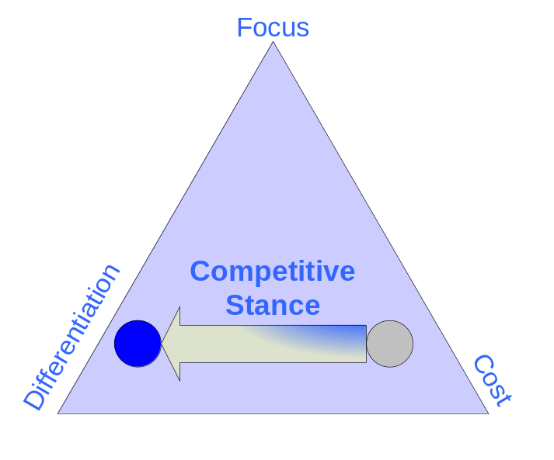
Porter’s competitive stance, shown above, is made up of three components: differentiation, focus, and cost. The chart is utilized by first placing the business as it currently stands within the triangle. Having properly audited the company, the marketer then decides where the business should move towards. This directly relates a marketer and client to analyze “where are we now?” and “where do we want to be?” This will develop how the company has a competitive advantage or superiority over other firms and competitors.
Dr. Nicosia’s dental practice is currently located in the cost section of the triangle. Higher prices due to his quality service and eighteen years experience seemed to be the main factor that separates him from other dentists. Unfortunately, using this as a competitive advantage also discouraged some customers that felt the higher prices were too much of an issue and went to other lower costing competitors.
Worthington Consulting would like to move Dr. Nicosia’s practice towards the differentiation portion of the triangle. If customers are able to see what makes Dr. Nicosia’s practice superior to other Rochester dentists they are far more likely to pay the slightly higher prices.
Our differentiating factor is the current affiliation with local Rochester professional sports teams and Dr. Nicosia’s specialization in sports dentistry. Worthington Consulting feels that this will show how distinctive Dr. Nicosia’s practice truly is.

how might we get there
This section of Worthington Consulting’s marketing plan entails the different methods used to obtain research, and how the analysis of this information helps us come up with various options from which our client can choose to implement to better their marketing strategy.

marketing research and relationship marketing
Worthington Consulting believes primary market research is needed in order to successfully implement a marketing plan. Primary market research consists of directly contacting the dental patients. Worthington Consulting, along with Element Z, the Internet Marketing consultancy group for our client, conducted a questionnaire that was left in Dr. Nicosia’s office to be filled out anonymously by the patients. Both groups felt that this was going to be an effective method to obtain primary data vital to the analysis and plannification of our marketing strategies. A total of 50 surveys, structured in multiple-choice, yes/no format, were produced. A copy of the actual survey, along with a tally of results, is provided.

Patient Interviews
In addition to patient contact through surveys, Worthington Consulting spent some time at Dr. Nicosia’s office to personally speak to some of his patients. Our results show that many of the patients choose to get treated by Dr. Nicosia because his father treated them. Almost all of the patients agreed that Dr. Nicosia has good bedside manner and that is something they look for in a dentist. All of the patients said that the best aspect of the practice is the people that work in the office, the doctors and the staff. Most of the patients that the research group spoke to said that they knew about Dr. Nicosia’s sports affiliation and they think that it’s great aspect of his practice. Speaking directly to patients really gave Worthington Consulting some deeper insight as to what his customer’s preferences are and how such data can be used to further develop the marketing plan.

Buyer Behavior Process

The buyer behavior process focuses on how customers buy products. This includes the thought process that a customer goes through before buying a product or service
This procedure can be reflected through a customer looking for a dentist. At first, a customer will address the problem. In this case, it would be that they needed dental care. This could be for an emergency reason, like a knocked out tooth, or for a routine check up. They might be unhappy with their current dentist, or just moved to the Rochester area and are searching for a new dentist.
The potential customer then begins searching for information. This could be through a variety of mediums including referrals from friends and family members, advertisements they have heard or seen, or merely by looking up local dentists in the area in the telephone book. After conducting patient interviews, it was discovered that most of Dr. Nicosia’s customers had either been referred by a relative or friend, or were patients of his father. A few also came to him because of his former location on East Avenue and followed him after moving to Brighton.
The process then continues as they weigh alternatives. Comparing and contrasting is done with the different options that they may choose from. Dr. Nicosia’s patients went through a similar contrast when they selected him. Many agreed that the friendly atmosphere and good bedside manner were key selling points. They enjoyed being able to select which hygienist they would be with, keeping each appointment consistent.
The purchase decision is then achieved. This would be when the customer books the appointment and comes into the office for the service. This is a key aspect of the process, when the decision they have made is heavily monitored by the individual customer.
Finally, another critical portion of the process is the conclusion, when the customer evaluates how they feel their decision was after the rendering of the service. For Dr. Nicosia’s patients, this would after they have visited with him and paid for the appointment and are left with deciding whether or not it was a positive experience. The patients of his that were interviewed all expressed very positive feelings about their experiences, even relatively new patients.

Relationship Marketing
In respect to Relationship Marketing there are two modes in which a business takes in order to define itself in its relationship to customers. A business can either focus on market share or customer loyalty (market share being the amount of market, in percentage, a business controls.) Pursuing market share has made many companies more concerned with finding new customers rather than maintaining with holding on to old ones. Such a marketing strategy can be disastrous for businesses in which a relationship is needed.
Relationship Marketing on the other hand relies on maintaining relationships with current customers in order to induce repeat business from them. The benefits of a Relationship Marketing strategy includes but is not limited to at least six areas: Reduced Marketing costs (customer acquisition costs more than customer retention); lower transaction costs (such as contract negotiating and order processing); Reduced customer turnover expense (fewer lost customers to replace); increased cross-selling success leading to a larger share of customers; more positive word-of-mouth; and, assuming loyal customers are also satisfied customers, Reduced failure costs (reduction in rework, warranty claims, and so forth).
The use of relationship marketing is essential to all businesses that are interested in their customers making multiple purchases (or for Nicosia Dental, repeat dental work). This naturally is important to the dental business. A returning customer is a customer who is no longer required to be enticed to come in for the initial business but has already established a relationship with a business. Keeping a customer loyal is both easier and more profitable than enticing a one-time price shopper to shop once. A marketing strategy incorporating good CRM (loyal customer management and retention strategies), and an effective plan for gaining new customers and transitioning them into loyal customers with relationship marketing is our ideal goal. Worthington Consulting understands the concept of relationship marketing is an almost innate marketing strategy for most businesses including yours.
A dental office requires slightly different relationship marketing strategies in comparison to say, a retail business. Customer retention is almost inevitable and customer selection of Nicosia Dental practice is not influenced strictly by its marketing activities but by external factors (insurance, etc.). This is not to say that a concrete relationship marketing plan is not in order. A good number of new customers are expected to come from word of mouth of existing customers. It is crucial to utilize this in order to retain current customers and to promote them to bring in new patients. Keep in mind that it is five times more expensive to bring in new customers, than it is to retain current ones. Hence, Worthington Consulting proposes the following Strategies (some of which are already being implemented but are crucial enough that they should be mentioned and continued to be used.

Clean / Welcoming Office Environment
Already being implemented, a clean office environment is crucial to the medical field. Beyond cleanliness, a minimalist approach to the waiting area and operation areas is beneficial in that it is reminiscent of the medical field. Smooth contours, appealing colors and a professionally dressed staff make going to the dentist less like an excruciating experience and more like a routine activity. The goal here is to allow patients to be at ease in the dental office which is stereotypically not associated with the dental profession.

Ability to Request Hygienist
Many patients likely have preferred hygienists. Loyal customers will likely find it very accommodating to be able to request or “reserve” their favorite hygienist preferably at the time in which they make their appointment.

Special Occasion Mailings
Utilizing the vast array of information available to you (due to extensive records inherent to the medical field) cards recognizing birthdays, holidays, births, death in families, anniversaries, and other special / notable occasion at the practices’ discretion should be mailed to patients. Clearly the cards should be professional and appropriate to the occasion.

Post-Procedure follow up mailings
Following each visit a patient makes to the practice a thank you card should be mailed. The letter should include at a minimum the patients name, the procedure that was done, and the time and date of the patients next appointment.

Pre-Procedure Reminder Mailings
Two weeks prior to a patient’s arrival to Dr. Nicosia a reminder mailing notice should be sent out of courtesy and convenience.

Focus on Family Convenience
One of the best sources of renewing a client base in dentistry is through the children of current clients. Utilizing this encourages and accommodates patients with children to make their appointments at the same time as their kids.

communications, pricing, and promotional strategies
Communications Strategies – Main Target Market

Through careful and systematical assessment of marketing research, Worthington Consulting has identified our main target market to be Sports-affiliated patients. This consists of athletic teams, particularly in the collegiate level, and the athletic fans that follow the teams. We plan to achieve a chain-reaction between the two groups, having the sports teams’ fans inquire about Dr. Nicosia’s Dental services after noting professional teams recognizing him as their team dentist. Worthington Consultants will communicate to sports fans and sports teams through the Reporter, radio, Smile of the Game, and to let sports fans know that there favorite athletes use Dr. Nicosia and so should they. With that approach, we believe that we effectively and efficiently touch both groups.

Communications Strategy – Weak Target Market

The weaker markets are the customers that are unaware of Dr. Nicosia’s sports affiliation. Worthington Consulting identifies two parties in this area: People that are not aware of Dr. Nicosia’s sports dentistry affiliation, and two, customers, either new or current, that are indifferent to sports. The second group focuses more in depth on new Rochesterians, people new to the area that are in search of a dentist, now that they cannot visit their old dentist due to travel distances. We consider this population to be an “average Joe” that can be swayed to come to Dr. Nicosia if the word gets out appropriately.
Advertising venues will be used for modes of communication between the dental practice and the target markets. Starting with brochures, they will be placed strategically at hot spots, such as real estate agencies, welcoming stations into Rochester, as well as travel agencies and hockey games, as well as the dental office itself, to further educate the current clientele. If Worthington Consulting can successfully implement the communication strategies for the stronger markets, then the weaker markets can also be reached on the same level. Dr. Nicosia will gain more customers by creating awareness of his affiliation with sports because customers interested in sports will be interested in having a dentist who can care for specific needs.

Brochures

Brochures are an effective and efficient way of getting information about a business to customers. If used properly, they can give customers an understanding about a business before they even enter the facility.
This could prove to be a very useful communication tool for Nicosia Dental. The brochure will intrigue new customers by showcasing his affiliation with various Rochester sports teams. It could help to encourage potential customers to become patients by expressing the friendly, professional, inviting atmosphere that they would experience upon arrival.
The brochure will be a three fold guide printed on high gloss paper in color. Its contents will consist of introductions to Dr. Nicosia and the office staff. Colored pictures of the waiting room, and operatories would help emphasize the atmosphere of the practice. Pictures of the Doctor with the Rochester Amerks, and other affiliated teams would be a great way to stress that these are truly patients of the practice.
An updated mission statement would help confirm the sincerity and genuine motives of the business. A list of the services that are offered, a schedule of operating hours, and a detailed map displaying the offices location will also be included. These aspects are arranged in a properly designed brochure and customers are guaranteed to respond.

Brochure Prices

Number of brochures produced is priced at $2.23 a brochure at Kinkos©. So, an approximate number of brochures, say, 300, would total $669.

Radio/Advertising/Hockey Venues and Prices

A list of the different communication venues is listed below in the table. Each is broken down into different scale marketing campaigns, with brief descriptions of what each contains, and at the end, an accurate estimate as to how much it would cost to implement the plans.

 | WITR  Weekdays 12-8pm | INFINITY Radio | REPORTER  Magazine | RIT Hockey | TOTALS
Small Scale | $180  20 Spots/ week | $750-2000  Monthly | ¼ Page:  $85/week | $2000  Small signs with optional small  TV/Radio slots | $3015-$4265  Monthly
Medium Scale | $240  30 Spots/ week | $2000-5000 Monthly | ½ Page:  $170/week | $4000-$7000  Back lighted signs in corners of arena | $6410-$11410  Monthly
Large Scale | $280  40 Spots/ week | $5000-Up  Monthly | Full Page:  $340/week | $10,000:  Scoreboard | $15620-Up  Monthly

After our analysis, Worthington Consulting has provided these different strategies that could be used in order to achieve our S.M.A.R.T objectives. All of these strategies need to be evaluated separately in order to see the different options that are available.

OPTION 1
One approach to this would be to turn Dr. Nicosia’s business into a brand name. A brand name would allow the practice to justify the premium prices because of the notoriety of the business. Optimally, we would like a person to hear the name Dr. Nicosia and automatically think of sports teams and sport dentistry, which in turn would automatically imply excellence in general dentistry. When a client is at an Amerks game and sees their favorite team member’s front tooth knocked out they should think “another job for Dr. Nicosia”. To properly develop a brand name a strong promotional plan is necessary and required. This would include heavy advertising especially at sports venues.
RIT men’s hockey has recently become a Division One team. Advertising could be done at the RIT rink for Dr. Nicosia, especially if he develops an affiliation with the team. Potential places for advertising in the arena include on the scoreboard, back lighted signs in the corners of the building and behind the goal, and in the tunnels of the building. Reasonably priced television and radio packages are also offered as a possibility. These advertisements would be done through the current RIT marketer. In addition, the Amerks’ affiliation to Nicosia Dental could be strengthened beyond just sponsoring the “Smile of the Game” program. This can be done by providing branded toothbrushes, floss, and a branded version of the hockey puck given within the package.

OPTION 2
Another possible way to achieve the objective would be to produce dental brochures for the practice. These brochures could include information about sports dentistry and the affiliated teams. Of course, information about Dr. Nicosia would also be included since it would be helpful for potential clients debating on whether or not they would like to become regular patients. As for potential clients, overviews of the staff and of the practice would also be included. These could be distributed at the office, at town halls, school administration buildings, real-estate offices, apartment complex offices, and other venues that newcomers to the area would visit upon arrival in Rochester.

OPTION 3
The third and final strategy involves more localized marketing, via 89.7 WITR Campus Radio and INFINITY Broadcasting Company©. Radio air spots, ranging from 30 seconds to a minute, would be used to launch an effective marketing campaign, which would include the name, location, and recognition of Nicosia Dental and Nicosia Sports Dentistry, and contact information for Dr. Nicosia’s dental practice. This would more than anything, target the entire Rochester population, and results are variable to many environmental effects concerning who listens to them and if the ad is very receptive to the clientele prospects.

which way is best
In order to achieve the S.M.A.R.T. Objectives, Worthington Consulting has selected a combination of two of the three possible options. We feel that these methods will prevail in establishing Dr. Nicosia’s dental practice as Rochester’s Sports Dentist, which will result in the gain of at least 300 new clients in a year, and help retain current ones.
The idea of establishing Dr. Nicosia sports dentistry specialization as a brand would be a fantastic and effective way for the business to justify its premium prices and bring in new clients. This will require intense communication marketing and promotion through television advertisements and radio commercial spots through RIT Hockey’s marketing program. In order for this to be a valuable tool for the practice, people must be aware of Dr. Nicosia and the fact that he is a sports dentist. Without this awareness, any effort in the branding process will be obsolete.
Aspects from the second option will also be used in the process. RIT Hockey is thought to be a highly valuable sector for Dr. Nicosia to branch off into. However, only so many clients will be reached in the sporting venues. In that case, the production and effective distribution of dental brochures will be in two targets. One will be the dental office for current patients who seek to learn more about their dentist. The other will be aimed at real estate agencies, apartment complexes, federal and public work buildings as well as Rochester information centers for new Rochesterians seeking a local, trustworthy dentist. This will productively spread awareness of both Nicosia Dental as a general dentist market leader, and a Rochester leader in sports dentistry.
Within this plan we have included a full contact list for which you can use to implement this marketing plan. Here is a step-by-step guide as to how to use this plan to the fullest of its capabilities.
Step 1: After thoroughly reading the marketing plan, begin communication strategies. To do this first decide what you can supply for the ‘Smile of the Game’ give away bag; branded toothbrushes, floss, and a hockey puck with your name on it and any thing else that we may have overlooked. After deciding this, contact the Rochester Americans General Hotline
Step 2: We have given you a range of prices regarding advertising venues, WITR, The Reporter, Infinity Broadcasting, and RIT hockey. We have decided that the best route of advertising is through RIT hockey and the Amerks use the contact list to make an appointment and to get the plans written in a contract.
Step 3: Look at the brochure that we have printed out. The prices that we have provided are from Kinko’s and they can produce enough brochures for you. When you have the brochures in hand, keep some at the office and have a staff member distribute them to the town hall, use your resources and ask patients who own there own business’s, preferably at businesses that we suggested, to leave a pile of brochures at their offices as well.
These three simple steps should get you on your way to get your office at full patient capacity. An important note of reminder, you need to evaluate the performance of the marketing plan that we have suggested in approximately one year. This will be discussed in the following section.

how do we ensure safe arrival
Ensuring Safe arrival from “where we are now” to “where we want to be” is the final portion in our five step marketing place. Ensuring safe arrival is considered to be the maintenance and contingency portion of the plan. By performing internal audits of incoming customers and retention of current customers as well as profitability of the corporation as a whole, a business is able to measure the success or lack success in the marketing plan. By setting up strategies in order to measure specific mediums of success (not just improved profitability but the specific marketing strategies which allowed this profitability) a business is able to refine its marketing strategy under the guidelines of the initial marketing plan.
During this final phase a business undergoes the same audit it did before the initial marketing process. Thus a cyclical pattern of constantly refining the marketing process is obtained. By continually reflecting on the progress of the business and where money is being made corrective actions can be taken to maximize profitability.

How to Evaluate Performance

Performance can be evaluated by using a number of methods. Depending on what the purpose of the business is different methods of evaluating the effectiveness of marketing strategies are implemented. Sales and performance analysis can be referenced by value, volume, market share, versus target, forecast, previous yeas, order size, regional expansion, return on investment, profit per unique customer, and number of complaints among others. For a dental practice implementing a new strategy, the most effective performance evaluation models are previous year versus current year in which the marketing strategy is being implemented and also volume, where volume is the amount of customers in comparison to the possible amount of customers.

Nicosia Dental Performance Standards are as Follows:

- Establish Dr. Nicosia as Rochester’s official sport dentist
- Obtain 25-30 new patients per month
- Have full capacity reached within 1 year after marketing plan is launched
- Maintain current clientele (have a maximum 1% retention loss within the first year)

Having now set these performance standards, Nicosia Dental should follow a cyclical performance evaluation that will compare new figures with the performance standards. The researchers feel Nicosia Dental see results for their dental practice. As far as measuring each standard, the following explanations will apply:

Monitor amount of customers

A periodical audit of retention rates is suggested. This is aimed at measuring the patient retention scheme of Worthington Consulting’s marketing plan. If a patient does not visit the office at least once in a twelve month period the patient is considered lost. These figures will of course be compared to prior year’s figures.
A progressive, continual audit of incoming new patients should also be carried out. Our measure is that for every inactive patient at least two new patients should be gained in order to be in a profitable zone. This is due to the fact that a current customer is more valuable than an incoming customer because they are less likely to leave the practice.

Get feedback from customers

The researchers find that the only way to obtain results in marketing is to ask the customers what it is they want. That was one of Worthington Consulting’s goals when carrying out the patient surveys and patient interviews. Using the polling of new customers Nicosia Dental will be able to obtain the most effective marketing strategies by keeping track of what medium brought the majority of new clients in. Money should be reinvested into the most effective marketing mediums respectively to the amount of revenue they bring in, pending that they have been cost effective, of course.
If most new clients are sports dentistry related, money should continue to be spent on hockey rink advertising and aforementioned other mediums. For customers coming in from personal references, or word of mouth, more attention should be paid to relationship marketing techniques which encourage customers to spread the word of the practice. If most new customers are new Rochesterians and heard of the practice through flyers and brochures at real-estate offices, then more efforts should be put into printing more brochures and covering more locations frequented by new residents of the area. Finally if a substantial amount of new clients were brought in by a technique other than strategies outlined here such a marketing strategy should be investigated for potential marketing growth. Once again, newly developed questionnaires will come into play here.
In addition to the questionnaires, Worthington Consulting suggests a direct comparison between demographics between the year our plan is implemented, and the prior year’s figures. This will give Nicosia Dental a direct look at whether or not clientele numbers have jumped significantly, or just reached a marginal increase. That will gives the dental practice the necessary information as to whether the marketing plan has been a success, or it needs to be improved.

Cost per Thousand
Cost per thousand is a mathematical process of determining effectiveness of a particular advertising medium. The calculation provides price per unique one thousand customers reached. Naturally, the lower the price per thousand of a medium the cheaper it is to reach each unique user. We have evaluated four mediums (Brochures, INFINITY Radio©, WITR Radio, and RIT Hockey Rink) and applied the cost per thousand model to each.

The Cost per thousand is calculated as followed:

(1000 people) X (Amount of users reached / cost of advertising) = cost per thousand

Brochures

(1000) X ($2.23 per brochure / # of brochures) = $2230 per thousand

Infinity Radio

(1000) X ($2000 / 77,000 people) = $25.97 per thousand

Where:
77,000 = one tenth of Rochester’s population (an approximation of the number reached)

WITR

(1000) X ($180 / 300 people) = $600 per thousand

RIT Hockey

(1000) X ($7000 / [2,000 + 500 (14)]) = $736 per thousand

Where:
2,000 = approximate capacity of RIT Ice Rink
500 = approximate new people at each hockey game
14 = number of hockey games per season

Summary of cost per thousand results.

Clearly brochures are the most expensive per thousand of all the mediums we investigated. However, we justify its cost in that each user we reach is already interested. As opposed to the radio or ice skating rink in which we are advertising to people who may or may not show an interest in Dr. Nicosia’s offerings. The avenue of using brochures is most effective because our advertising target is self selecting. It takes an interest to pick up a brochure.
We feel that currently Infinity Radio is too expensive despite their low cost per thousand offering. They reach an extremely large number of potential customers however the cost in doing such as very expensive. And since a sustainable advertising scheme over the radio is required our current budget does not have room for infinity radio. WITR proves to be an ineffective medium for advertising so we are not recommending its use at this time.
Concluding with this model, Worthington Consulting finds that at this point, the models and plans of action to control the marketing process provided by the researchers correctly evaluate the dental practice’s performance. It would be a matter of getting this out into the light, and preparing to take corrective action.

Adjusting Marketing Activity and Contingency Plan

Whether it depends on adjusting the current marketing actions slightly to accommodate Nicosia Dental’s marketing approach, or a heavy change to move towards more revenues, it will depend on constant audits of the firm, if not yearly, then strongly recommend on a monthly or bi-yearly basis.
Worthington Consulting firmly believes sports dentistry, being established as the main focus in advertising, to bring positive results for the dental practice. We suggest its use in garnering business through all of our advertising channels; Brochures and Hockey advertising. However, using sports dentistry to gain all business is a fresh idea, and thus, creates a heavy gamble. Therefore, if after a year the amount of acquired patients does not forecast that their revenue will overcome marketing costs a contingency plan should be implemented.
Because advertising to sports fans as a strategy is possibly not as fruitful as we anticipate our more traditional concept of marketing to average customers at locations which are frequented to new residents should be more heavily pursued. Incorporating the benefit of being associated with sports dentistry should remain. However, targeting clients using only a sports affiliation should be abandoned. It is important to note that abandoning the avenue of marketing centered on sports affiliation will not affect using it in targeting and promoting the business using more traditional advertising venues.
These strategies will be monitored and evaluated by Worthington Consulting. The researchers will set up a private electronic mail account, as WorthingtonConsulting@gmail.com, for use of auditing Nicosia Dental’s progress after the implementation of the marketing plan. Worthington Consulting will ask Nicosia Dental to send Demographic figures, as well as revenue/cost numbers to conduct a financial analysis and make recommendations to improve and/or adjust. This cycle will continue for as long as Nicosia Dental requires it, and is discussed with Worthington Consulting.

Honest Appraisal
Worthington Consulting has spent a great deal of time and effort using both marketing knowledge and experience to the fullest in order to achieve a comprehensive analysis of the dental practice of Dr. Nicosia. Although, we realize that there are limitations to the work compiled in the previous report.
Worthington Consulting had a time restriction of eight weeks to create this marketing plan for Dr. Nicosia. The consultancy realizes that particular areas could have been researched more thoroughly, but were done so to the greatest of their ability in the time given.
A greater amount of primary research with customers could have also helped to emphasize the objectives and strategies that Worthington Consulting explained and used in the marketing plan. Although a great deal of information was acquired through the questionnaires, more effective use of personal interviews could have helped to solidify the decisions made by the consultancy. It would have also been pertinent to interview customers from competitor’s practices to help define any limitations that the consultancy may have overlooked.
Worthington Consulting presents this information with pride to Dr. Nicosia’s practice. It is hoped, that despite any limitations the consultants may have incurred, Dr Nicosia can implement these ideas and strategies to improve on an already successful and stable business.

Appendices

APPENDIX A - Nicosia Dental Patient Survey
Dr. Nicosia’s Dental Office Patient Survey

Please take time to answer this short survey. The survey will be kept anonymous
(Please circle one answer or fill in the response):

1) What is your gender?
Male Female

2) Under what age group would you fall under?

16-21 yrs old 22-45 yrs old 46-70 yrs old 70 and older

3) How long have you been a patient of Dr. Nicosia?

- How would you rate the office environment? (1-Needs Improvement, 10-Excellent)

1 2 3 4 5 6 7 8 9 10

5) Were you aware that Dr. Nicosia provides service to local sports teams (i.e. Amerks)?

Yes No

6) Do you have Internet access at home?

Yes No

a. If so, do you have a high speed connection?

Yes No Unsure

- Would you be interested in visiting a website for Dr. Nicosia’s office?

Yes No

8) Would you feel comfortable scheduling appointments online?

Yes No

9) Would you be interested in email reminders regarding your scheduled appointments?

Yes No

10) Would you use an online chat to ask a question to our staff?

Yes No- I’d prefer to call

Appendix B - Patient Survey Tallied Results
Gender | Age Group | How Long as a Patient | Office Rating | Aware of Sports Dentistry? | Internet @ Home: w/ High Speed? | Website for Dr. Nicosia? | Online Appts? | Emails for Appts? | Online Chat?
M | 46-70 | 2 yrs | 10 | No | Yes, Unsure | Yes | No | Yes | Yes
M | 46-70 | Since 83 | 10 | No | Yes, Yes | Unsure | Yes | Yes | Maybe
M | 46-70 | 16 yrs | 8 | Yes | Yes, Yes | No | No | No | No
F | 46-70 | 33 yrs | 9 | Yes | Yes, Yes | Yes | Yes | Yes | Yes
F | 22-45 | 21 yrs | 9 | Yes | Yes, Yes | No | No | Yes | No
M | 46-70 | 20+ yrs | 9 | Yes | Yes, Yes | Yes | Yes | Yes | Yes
F | 46-70 | 22 yrs | 10 | Yes | Yes, Yes | Yes | Yes | Yes | Yes
M | 70+ | 32 yrs | 10 | No | Yes, No | Yes | Yes | Yes | No
F | 22-45 | 18 yrs | 10 | No | Yes, Yes | Yes | Yes | Yes | Yes
M | 46-70 | Since 85 | 9 | Yes | Yes, Yes | Yes | Yes | Yes | Yes
M | 22-45 | 2.5 yrs | 10 | No | Yes, Yes | Yes | Yes | Yes | Yes
M | 46-70 | 39 yrs | 10 | Yes | Yes, No | Yes | Yes | Yes | Yes
F | 46-70 | 15 yrs | 10 | No | Yes, No | Yes | Yes | Yes | Yes
M | 46-70 | N/A | 10 | No | Yes, Yes | Yes | Yes | Yes | Yes
F | 22-45 | 1 Day | 10 | No | Yes, Yes | Yes | Yes | Yes | Yes
M | 70+ | 42 yrs | 10 | Yes | Yes, Unsure | No | No | Yes | No
M | 46-70 | Since 62 | 10 | No | Yes, Yes | Yes | Yes | Yes | No
F | 22-45 | Since 82 | 10 | No | Yes, Yes | Yes | Yes | Yes | Yes
M | 70+ | 14 yrs | 10 | Yes | No | No | No | No | No
F | 70+ | 16 yrs | 8 | Yes | Yes, No | Yes | Yes | Yes | Yes
F | 22-45 | 22-45 | 10 | Yes | Yes, Yes | Yes | Yes | Yes | Yes
F | 70+ | 18 yrs | 10 | Yes | Yes, Yes | Yes | Yes | Yes | Yes
M | 22-45 | N/A | 10 | Yes | No | No | Yes | Yes | Yes
F | 46-70 | Since 9 yrs | 10 | No | Yes, Unsure | Yes | Yes | Yes | Yes
F | 22-45 | 5+ yrs | 10 | Yes | Yes, Yes | Yes | Yes | Yes | Yes
F | 22-45 | 7 yrs | 10 | No | Yes, Yes | Yes | Yes | Yes | No
M | 46-70 | 6+- yrs | 10 | Yes | Yes, Yes | No | Yes | Yes | Yes
M | 46-70 | 40+ yrs | 10 | Yes | Yes, Yes | No | Yes | Yes | Yes
F | 22-45 | 3 yrs | 9 | No | No | Yes | Yes | Yes | No
M | 46-70 | 11 yrs | 10 | Yes | Yes, Yes | No | Yes | Yes | No
F | 16-21 | 17 yrs | 10 | Yes | Yes, Yes | Yes | Yes | Yes | No
F | 46-70 | N/A | 8 | No | Yes, Yes | No | Yes | Yes | Yes
F | 46-70 | 10 yrs | 10 | Yes | Yes, Yes | No | No | Yes | No
M | 46-70 | Since 66 | 10 | Yes | Yes, Yes | No | No | No | No
M | 46-70 | Since start | 10 | yes | Yes, Yes | Yes | Yes | Yes | Yes
F | 22-45 | 6 yrs | 10 | No | Yes, Yes | Yes | Yes | Yes | Yes
M | 46-70 | 10 yrs | 8 | Yes | Yes, Yes | Yes | Yes | Yes | Yes
M | 46-70 | 15+ yrs | 10 | No | Yes, Yes | Yes | Yes | Yes | Yes
F | 46-70 | Since 97 | 10 | Yes | Yes, Yes | Yes | Yes | Yes | Yes
M | 22-45 | 1.5 yrs | 10 | No | Yes, Yes | Yes | Yes | Yes | No

Appendix C – American Dental Association Search Query for Dr. Nicosia
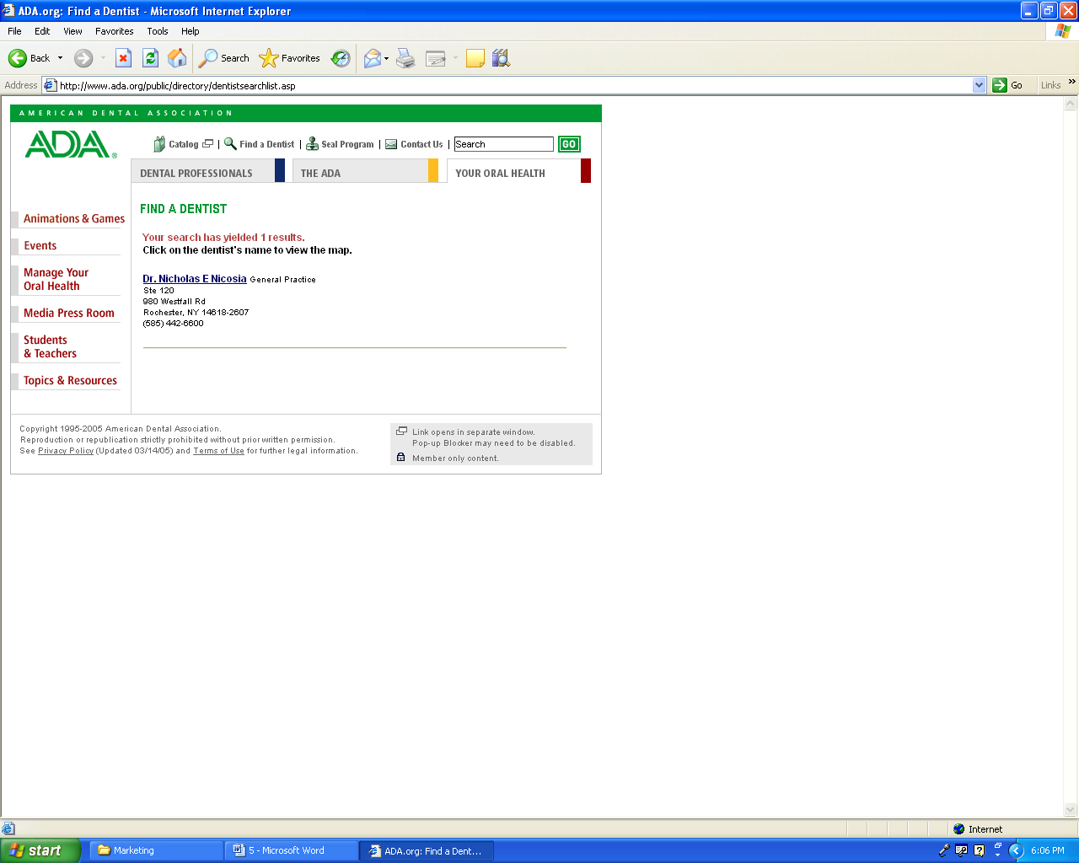

Appendix D – Yellowpages.com search results for Dr. Nicosia in Rochester
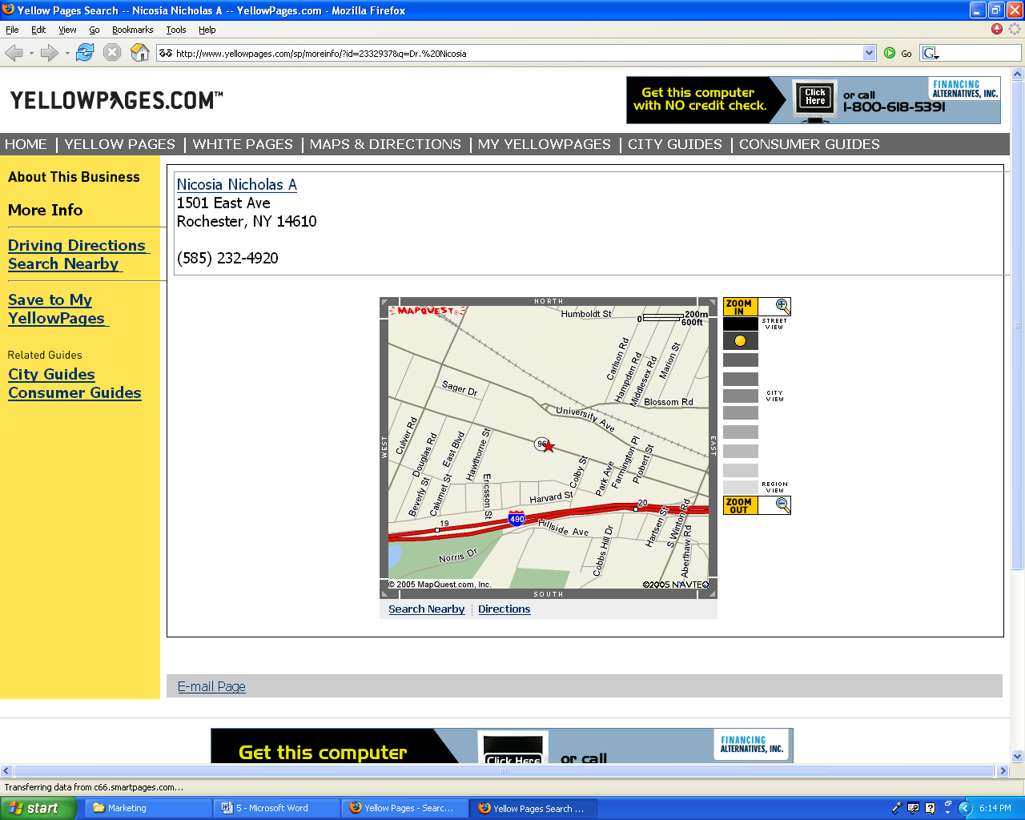

Appendix E – SportsDDS.com: A Sports Dentistry Website Based in NYC
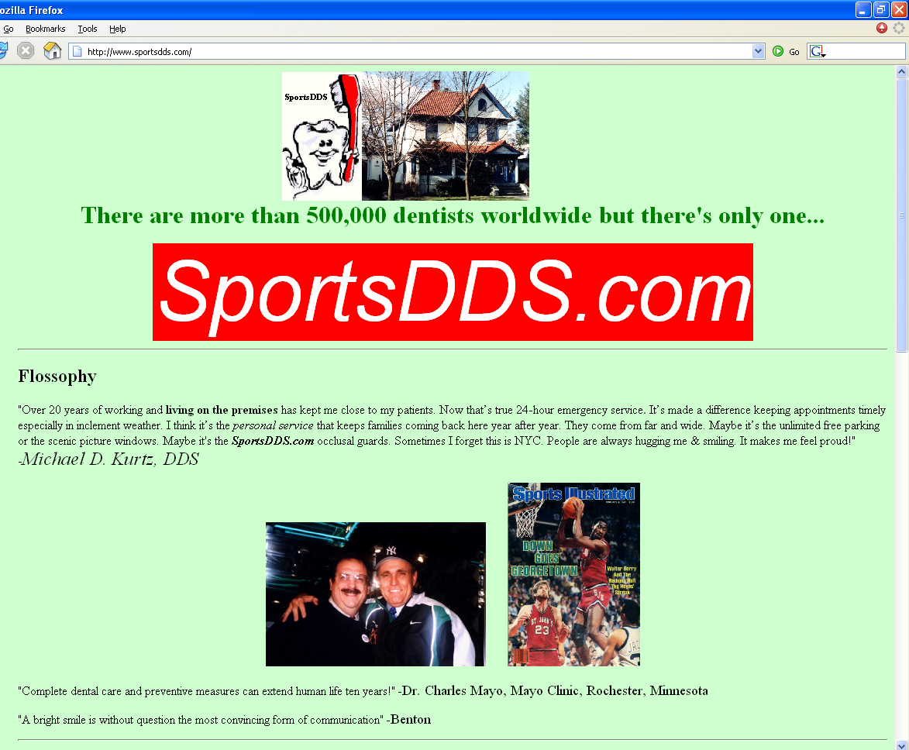

Appendix F – Sportsdentistry.com: Online source for Sports Dentistry
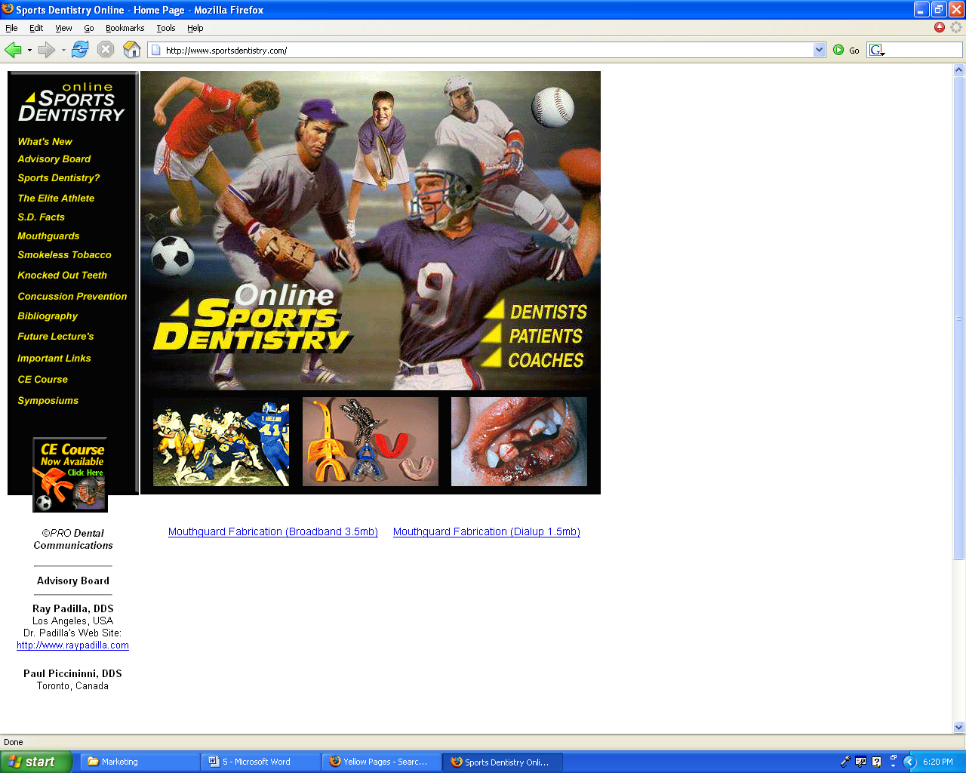

Appendix G – Contact Information for Marketing Venues

INFINITY Radio©
Richard Nightingale – Head of Marketing Department 96 WCMF Rochester
http://www.965wcmf.com/Home.aspx
(585) 399-5722
richard.nightingale@infinitybroadcasting.com

89.7 WITR Campus Radio
Teresa Castillo – Promotions Director
Txc1314@rit.edu
585-475-2000
http://www.modernmusicandmore.com/index.html

Rochester Institute of Technology Hockey Program Marketing
Vince Petrone
(585) 303-8023

Rochester Americans General Hotline
http://www.Amerks.com
(585) 454-5335

Bibliography

Formisano, R., 2003. Manager’s Guide to Strategy. New York: McGraw-Hill Trade, 108.

Gilligan, C and Wilson, R.M.S., 2003. Strategic Marketing Planning. Oxford: Butterworth-Heinemann.

Griffin, J., 2002. Customer Loyalty: How to Earn it and How to
Keep it. San Francisco: Jossey-Bass.

Grundy, T., 2003. Gurus on Business Strategy. London: Thorogood, 58.

Kaplan, R.S., 2005. How the Balanced Scorecard Complements the McKinsey 7-S Model. Strategy & Leadership (Online), 33 (3) 41-47. ProQuest. Available from: http://www.proquest.com (Accessed on 17 Nov 2005)

Kotler, P. AND Armstrong, G., 2004. Principles of Marketing. 10th ed. New Jersey: Pearson Education, 574.

McLean, F., 1996. Marketing the Museum. London: Routledge, 196.

Paley, N., 2001. Marketing Strategy Desktop Guide. London: Thorogood, 58.

Shepard, D., AND Associates Staff, 1999. New Direct Marketing: How to Implement a Profit-Driven Database Marketing Strategy. 3rd ed. New York: McGraw-Hill Professional, 434.

Tack, A., 1992. Profitable Customer care: win increased market share and boost profits. Oxford: Butterworth-Heinemann

http://www.ada.org/ [16 Nov 2005]

http://www.census.gov/ [16 Nov 2005]

http://www.drvanbutsele.com/bvb-maxiofacial.htm [16 Nov 2005]

http://sportsdds.com [16 Nov 2005]

http://www.sportsdentistry.com/sportsdentirsty.html [16 Nov 2005]

http://www.yellowpages.com/sp/ [16 Nov 2005]

See Appendix D
Formisano, R., 2003. Manager’s Guide to Strategy. New York: McGraw-Hill Trade, 108.
McLean, F., 1996. Marketing the Museum. London: Routledge, 196.
Paley, N., 2001. Marketing Strategy Desktop Guide. London: Thorogood, 58.
Grundy, T., 2003. Gurus on Business Strategy. London: Thorogood, 58.
Kaplan, R.S., 2005. How the Balanced Scorecard Complements the McKinsey 7-S Model. Strategy & Leadership (Online), 33 (3) 41-47. Proquest. Available from: http://www.proquest.com (Accessed on 17 Nov 2005).
http://www.census.gov [16 Nov 2005]
Kotler, P. AND Armstrong, G., 2004. Principles of Marketing. 10th ed. New Jersey: Pearson Education, 574.
See Appendix A and B
See Appendix G
Shepard, D. AND Associates Staff, 1999. New Direct Marketing: How to Implement a Profit-Driven Database Marketing Strategy. 3rd ed. New York: McGraw-Hill Professional, 434.

